App Flow Document: Cancer Care & Cure Foundation Website
Version 1.0 (Draft) | 24 October 2026 | Companion to the PRD and TRD | Status: For review

1. Purpose
This document describes how visitors move through the website and what happens at each step: entry points, navigation, page-to-page paths, form journeys, error states and the behind-the-scenes flow of each submission. It is meant for designers, developers and the foundation's team to agree on the experience before the site is built.

2. User Types and Goals
User | Main goal | Primary path
Patient or family member | Find out whether the foundation can help and ask for assistance | Home, Patient Assistance, Contact
Individual donor | Check the foundation is genuine and find a safe way to give | Home, About, Donate, Contact
CSR or corporate partner | Understand focus areas and start a partnership conversation | Home, CSR Partnerships, Contact
Volunteer | Learn about roles and apply | Home, Volunteer, form
Doctor or partner organisation | Assess credibility and reach the team | About, Programmes, Contact

3. Entry Points
- Search engines (for example, cancer patient support Delhi), landing on Home, Patient Assistance or Programmes.
- Direct link or social media share, landing on Home, Donate or Volunteer.
- WhatsApp or email links sent by the foundation, landing on Patient Assistance, Donate or Contact.
- QR codes on posters or flyers, landing on Home, Volunteer or Contact.
- Referral from a hospital or partner website, landing on Patient Assistance or About.
Every entry page must show the main navigation, a clear next step, and the WhatsApp button.

4. Site Map and Navigation

4.1 Site map
The site map is drawn in the diagram below.
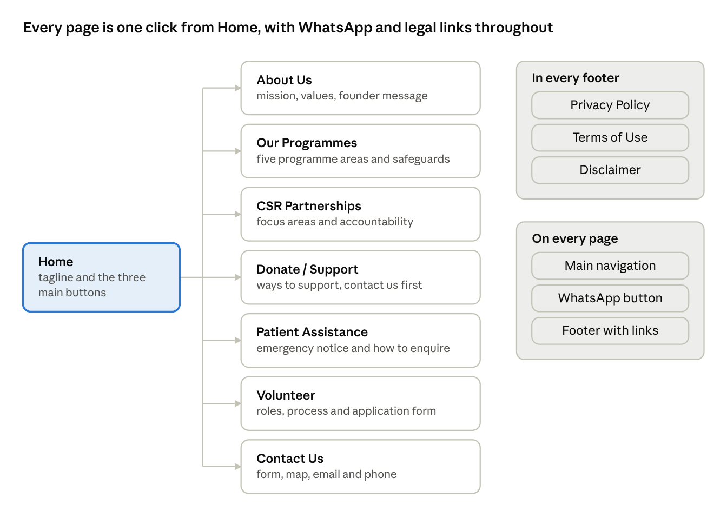
site map · 8 pages, 3 legal pages
The seven main pages hang off Home, and the footer links and WhatsApp button follow the visitor everywhere.

4.2 Navigation rules
- Header (all pages): Logo (links to Home), main menu (Home, About Us, Our Programmes, CSR Partnerships, Donate, Patient Assistance, Volunteer, Contact Us). On mobile the menu collapses into a button with a full-screen or slide-in panel.
- Primary calls to action: "Get Help" (Patient Assistance), "Donate" (Donate page), "Volunteer" (Volunteer page). Shown on Home and repeated at the end of key pages.
- Footer (all pages): Privacy Policy, Terms of Use, Disclaimer, contact email, social links, short disclaimer line.
- Floating WhatsApp button (all pages): Opens WhatsApp chat in a new tab.
- Breadcrumbs: Not needed in Phase 1 because the structure is shallow.
- 404 page: Friendly message with links to Home, Patient Assistance and Contact.

5. Page-by-Page Flow

5.1 Home
- Visitor sees the tagline, a short statement of the foundation's vision and three primary buttons: Get Help, Donate, Volunteer.
- Scrolls to "How we hope to help" with links to Programmes and Patient Assistance.
- Sees quick links to About Us and CSR Partnerships.
- Reaches the footer with legal links and contact details.
Exits: Patient Assistance, Donate, Volunteer, About, Programmes, CSR, Contact.

5.2 About Us
- Reads who we are, mission and objectives.
- Reads the values and the founder message.
- Sees a call to action to read about Programmes or contact the team.
Exits: Programmes, Contact, Donate.

5.3 Our Programmes
- Sees the five programme areas as cards.
- Opens a programme section to read details and safeguards.
- Each programme ends with a link to Patient Assistance or Volunteer as relevant.
Exits: Patient Assistance, Volunteer, Contact.

5.4 CSR Partnerships
- Reads collaboration areas and accountability principles.
- Reads the notice that registration and tax exemption status must not be assumed.
- Clicks "Discuss a partnership", which goes to the Contact page with the enquiry type preselected as CSR partnership.
Exits: Contact, About.

5.5 Donate / Support
Phase 1 (launch):
- Reads ways to support and the transparency note.
- Sees the instruction to contact the foundation before donating and the warning against unofficial payment requests.
- Clicks "Contact us to donate", which goes to Contact with the enquiry type preselected as donation.
Phase 2 (after legal and bank approval):
- Chooses an amount and enters name, email and consent.
- Is taken to the payment gateway's hosted checkout.
- Returns to a thank-you page; receives an email receipt.
- If payment fails, sees a clear message and can retry or contact the team.

5.6 Patient Assistance
- First sees the emergency notice: the foundation is not an emergency service; call the treating hospital or local emergency services for urgent symptoms.
- Reads who can enquire, how to enquire, and the limits of assistance (no guarantee, subject to availability and verification).
- Reads the sensitive-information notice (do not send medical records or ID numbers through the form).
- Clicks "Contact us for assistance", which goes to Contact with the enquiry type preselected as patient assistance, or clicks the WhatsApp button.
Exits: Contact, WhatsApp, Programmes.

5.7 Volunteer
- Reads roles and the volunteer process.
- Fills in the volunteer form (name, email, phone, city, role, skills, availability, consent).
- Submits and sees a confirmation; the foundation reviews and responds.

5.8 Contact Us
- Sees email, phone, address and the map section.
- Fills in the contact form (name, email, phone, enquiry type, message, consent), after reading the form notice.
- Submits and sees a confirmation message.
- Can also click the email link, phone link, WhatsApp button or "Open in Google Maps".

5.9 Legal pages
Privacy Policy, Terms of Use and Disclaimer are reached from the footer and from links next to the forms. Each ends with a link back to Contact for questions.

6. Core User Journeys

6.1 Patient or family member seeking help
- Arrives from search or a shared link.
- Reads the Patient Assistance page and the emergency notice.
- Decides to reach out by form or WhatsApp.
- If using the form: submits without sensitive documents and sees a confirmation with the expected response approach.
- The foundation team reviews, contacts the person, and handles verification offline.
- The enquiry status is updated internally (new, in progress, closed).
Success: The person feels informed, safe and clear about the next step.

6.2 Donor
- Arrives on Home or Donate.
- Checks About Us and the transparency note.
- Phase 1: contacts the foundation and receives verified payment details directly from the team. Phase 2: donates through the gateway and receives a receipt.

6.3 CSR partner
- Opens CSR Partnerships and reads the focus areas and compliance notes.
- Submits the contact form with the enquiry type CSR partnership.
- The foundation responds with documents and next steps.

6.4 Volunteer
- Opens Volunteer, reviews roles.
- Submits the volunteer form.
- Receives a confirmation; the team contacts shortlisted applicants.

7. Form Submission Flow (System View)
The contact and volunteer forms follow the same system flow, drawn in the diagram below.
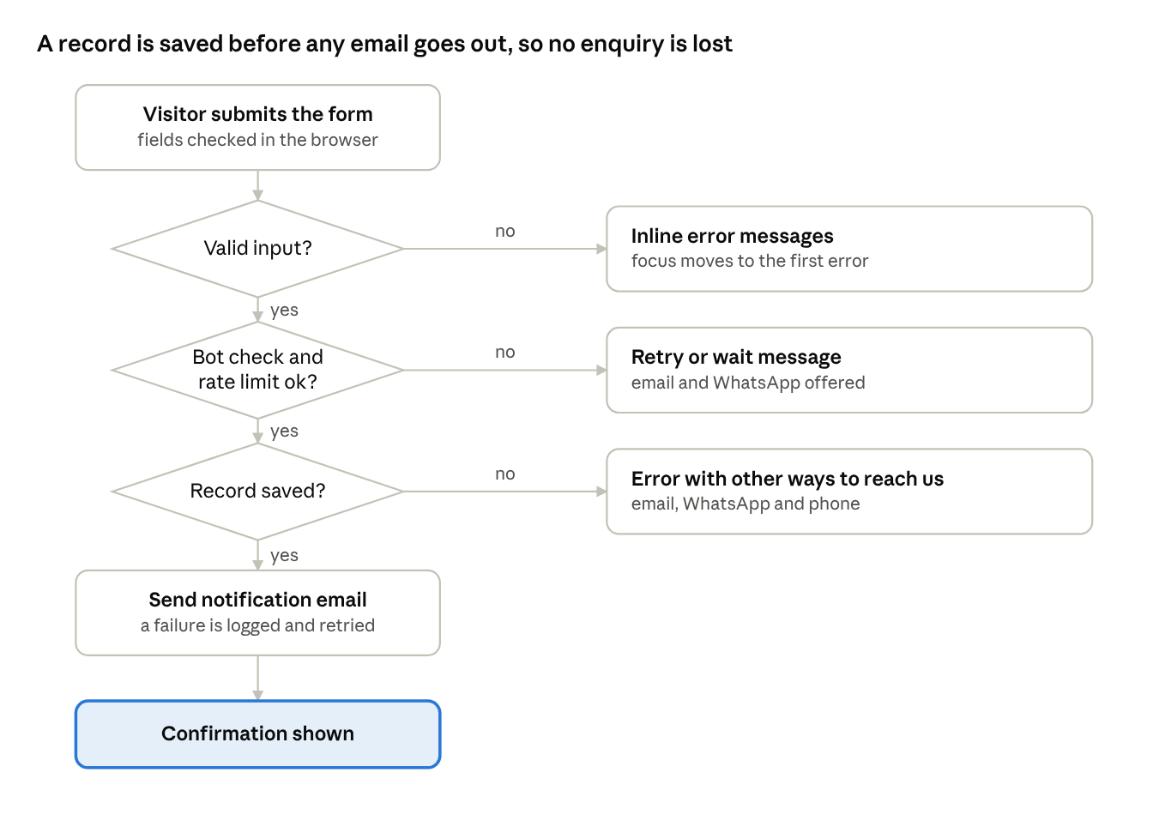
form submission flow · 3 decisions, 3 exits
Three checks can stop a submission, and each exit gives the visitor a clear next step; the record is saved before the notification email is attempted.

7.1 States and messages
State | What the user sees
Idle | Empty form with labels, required marks and the privacy and sensitive-information notice
Validating | Inline messages next to each invalid field; focus moves to the first error
Submitting | Button shows a loading state and is disabled to prevent double submits
Success | Confirmation message with what happens next; form cleared; link back to Home
Validation error (server) | Same inline messages as client validation
Rate limited | Message asking the person to wait and try again, with email and WhatsApp as alternatives
Bot check failed | Message asking the person to retry the check
System error | Generic apology and alternative contact routes (email, WhatsApp, phone); no data lost silently

8. Phase 2: Donation Flow (System View)
The online donation flow is drawn in the diagram below. It applies only after legal registration, bank setup and receipt rules are confirmed in writing.
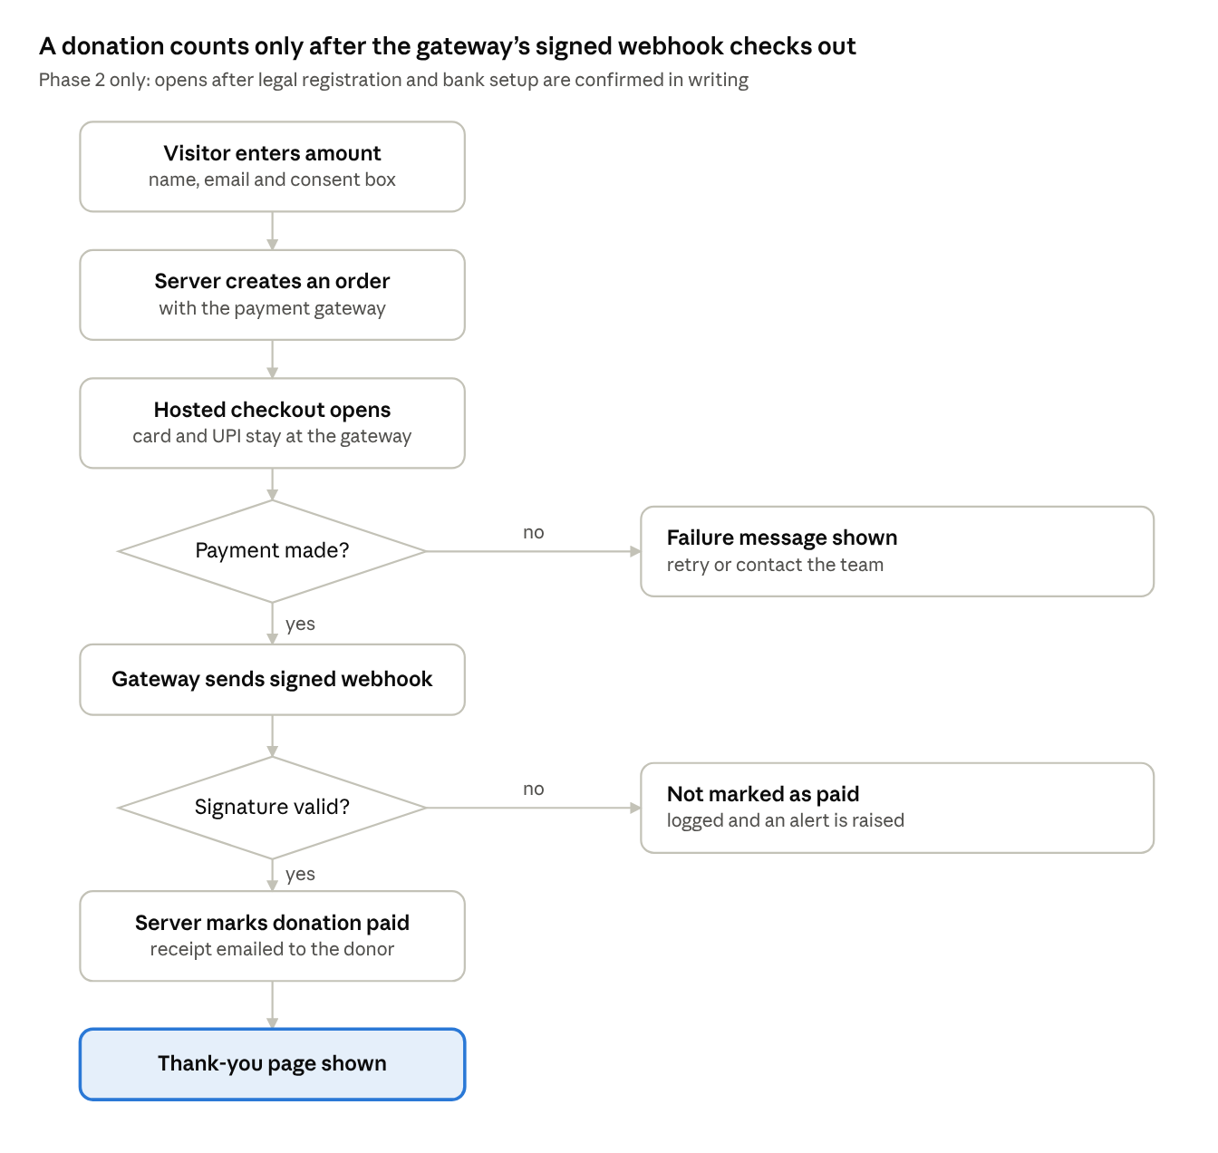
donation flow · 2 decisions, phase 2 only
The browser's return from checkout is never trusted on its own; the server marks a donation paid only after it verifies the gateway's signed webhook.

9. Staff and Admin Flow
- A new submission arrives in the database and the foundation's notification email.
- A staff member opens the submission list (database dashboard or a protected admin view in Phase 2).
- They set the status to in progress and add internal notes.
- They contact the person by phone, email or WhatsApp.
- When resolved, they set the status to closed.
- Records are retained or deleted according to the agreed retention policy; deletion requests are handled through a documented process.

10. Global Behaviours and Edge Cases
- Mobile first: All flows must work with one hand on a small screen; buttons at least 44 by 44 pixels.
- Slow connection: Pages load text first; map loads only when requested; forms keep entered data if a submission fails.
- JavaScript disabled or blocked: Content and contact details remain readable; forms show the email and phone as a fallback.
- WhatsApp not installed: Link opens WhatsApp Web or the store page; the email and phone remain available.
- Back button: After success, the back button must not resubmit the form.
- Cookie notice: Shown only if non-essential cookies are used; the choice is remembered.
- Language (Phase 2): A language toggle in the header switches between English and Hindi on the same page.
- Accessibility: Full keyboard use, screen-reader labels, visible focus, and clear error announcements throughout.

11. Content and Messaging Rules in Flows
- Never promise assistance, timelines or outcomes; use cautious wording such as "aims to" and "subject to availability".
- Never show tax, 80G or CSR-1 claims until verified.
- Never ask for medical records, ID numbers or bank details in the general forms.
- Keep the emergency notice and the fraud-awareness warning visible where they apply.

12. Analytics Events to Track
Event | Where | Purpose
cta_click_get_help, cta_click_donate, cta_click_volunteer | Home and other pages | See which paths visitors choose
form_start and form_submit_success (contact, volunteer) | Forms | Measure completion rate
form_error (by type) | Forms | Find friction points
whatsapp_click | Floating button | Measure messaging interest
map_load, phone_click, email_click | Contact | Measure contact methods
donate_contact_click (Phase 1), donation_start and donation_success (Phase 2) | Donate | Measure giving funnel
Use privacy-friendly analytics and do not record personal data or form contents.

13. Open Questions
- What response time should the confirmation message mention, if any?
- Should the contact form preselect the enquiry type from links on other pages, as described above?
- Will the foundation add a protected admin view in Phase 2, or keep using the database dashboard?
- Should the site show a short "what happens next" timeline after a patient enquiry?
- Which languages should the first version support? - english

